Builder Pattern
# Source: AI Source: Provided by: [Data Path: Persons Table -> ID Column: 1, Name_En Column: Motasem Essam] -> From: [ChatGPT] on [1/23/2026]
The Builder Pattern separates the construction of a complex object from its representation, allowing the same construction process to create different representations.
👉 Think of it like building a custom pizza: the chef assembles the pizza step by step, and the customer can choose different toppings, crust, or size.

🔑 Key Points
# Source: AI Source: Provided by: [Data Path: Persons Table -> ID Column: 1, Name_En Column: Motasem Essam] -> From: [ChatGPT] on [1/23/2026]
• Useful for constructing complex objects step by step
• Allows creation of different representations using the same process
• Promotes readability, maintainability, and flexibility

❌ Bad Example
# Source: AI Source: Provided by: [Data Path: Persons Table -> ID Column: 1, Name_En Column: Motasem Essam] -> From: [ChatGPT] on [1/23/2026]
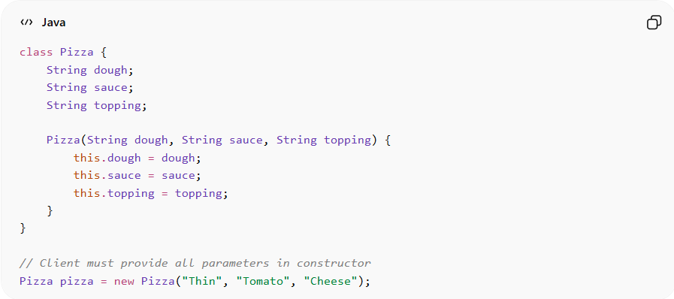
class Pizza {
String dough;
String sauce;
String topping;

Pizza(String dough, String sauce, String topping) {
this.dough = dough;
this.sauce = sauce;
this.topping = topping;
}
}

// Client must provide all parameters in constructor
Pizza pizza = new Pizza("Thin", "Tomato", "Cheese");
Problems:
• Constructor with many parameters → hard to read and maintain
• Adding new options requires modifying constructor
• Client knows internal construction details

✅ Good Example
# Source: AI Source: Provided by: [Data Path: Persons Table -> ID Column: 1, Name_En Column: Motasem Essam] -> From: [ChatGPT] on [1/23/2026]
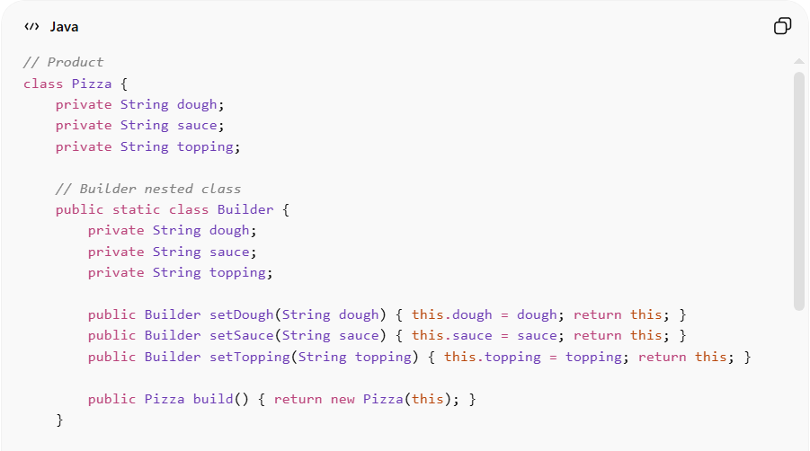
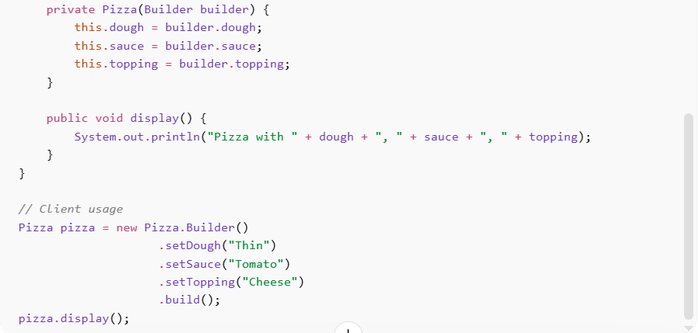
// Product
class Pizza {
private String dough;
private String sauce;
private String topping;

// Builder nested class
public static class Builder {
private String dough;
private String sauce;
private String topping;

public Builder setDough(String dough) { this.dough = dough; return this; }
public Builder setSauce(String sauce) { this.sauce = sauce; return this; }
public Builder setTopping(String topping) { this.topping = topping; return this; }

public Pizza build() { return new Pizza(this); }
}

private Pizza(Builder builder) {
this.dough = builder.dough;
this.sauce = builder.sauce;
this.topping = builder.topping;
}

public void display() {
System.out.println("Pizza with " + dough + ", " + sauce + ", " + topping);
}
}

// Client usage
Pizza pizza = new Pizza.Builder()
.setDough("Thin")
.setSauce("Tomato")
.setTopping("Cheese")
.build();
pizza.display();
Benefits:
• Construction separated from representation
• Code is readable and maintainable
• Supports optional parameters and multiple representations
• Reduces complex constructor overloads

⚡ Advantages
# Source: AI Source: Provided by: [Data Path: Persons Table -> ID Column: 1, Name_En Column: Motasem Essam] -> From: [ChatGPT] on [1/23/2026]
• Clear step-by-step construction
• Flexible for different configurations
• Encapsulates construction logic
• Improves code readability

⚠️ Disadvantages
# Source: AI Source: Provided by: [Data Path: Persons Table -> ID Column: 1, Name_En Column: Motasem Essam] -> From: [ChatGPT] on [1/23/2026]
• More classes and code compared to simple constructors
• Overhead may be unnecessary for simple objects
• Builder pattern can be verbose

🛠️ Use Cases
# Source: AI Source: Provided by: [Data Path: Persons Table -> ID Column: 1, Name_En Column: Motasem Essam] -> From: [ChatGPT] on [1/23/2026]
• Complex objects with many optional parts – Pizza, Cars, Computer configurations
• Immutable objects – Objects that cannot be modified after creation
• Stepwise construction needed – Document generators, Reports, or UI builders
• Avoiding constructor parameter chaos – when constructors have many optional parameters

